

Semester Two Examination, 2021

Question/Answer booklet

SPECIALIST MATHEMATICS
UNITs 3 & 4

Section One:

Calculator-free

Your Name

Your Teacher’s Name

Time allowed for this section
Reading time before commencing work: five minutes
Working time: fifty minutes

Materials required/recommended for this section
To be provided by the supervisor
This Question/Answer booklet
Formula sheet

To be provided by the candidate
Standard items: pens (blue/black preferred), pencils (including coloured), sharpener, correction fluid/tape, eraser, ruler, highlighters

Special items: nil

Important note to candidates
No other items may be taken into the examination room. It is your responsibility to ensure that you do not have any unauthorised material. If you have any unauthorised material with you, hand it to the supervisor before reading any further.
Question | Mark | Max | Question | Mark | Max
1 |  |  | 5
2 |  |  | 6
3 |  |  | 7
4 |  |  | 8

Structure of this paper

Section | Number of questions available | Number of questions to be answered | Working time (minutes) | Marks available | Percentage of examination
Section One:  Calculator-free | 8 | 8 | 50 | 51 | 35
Section Two:  Calculator-assumed | 13 | 13 | 100 | 101 | 65
 |  |  |  | Total | 100

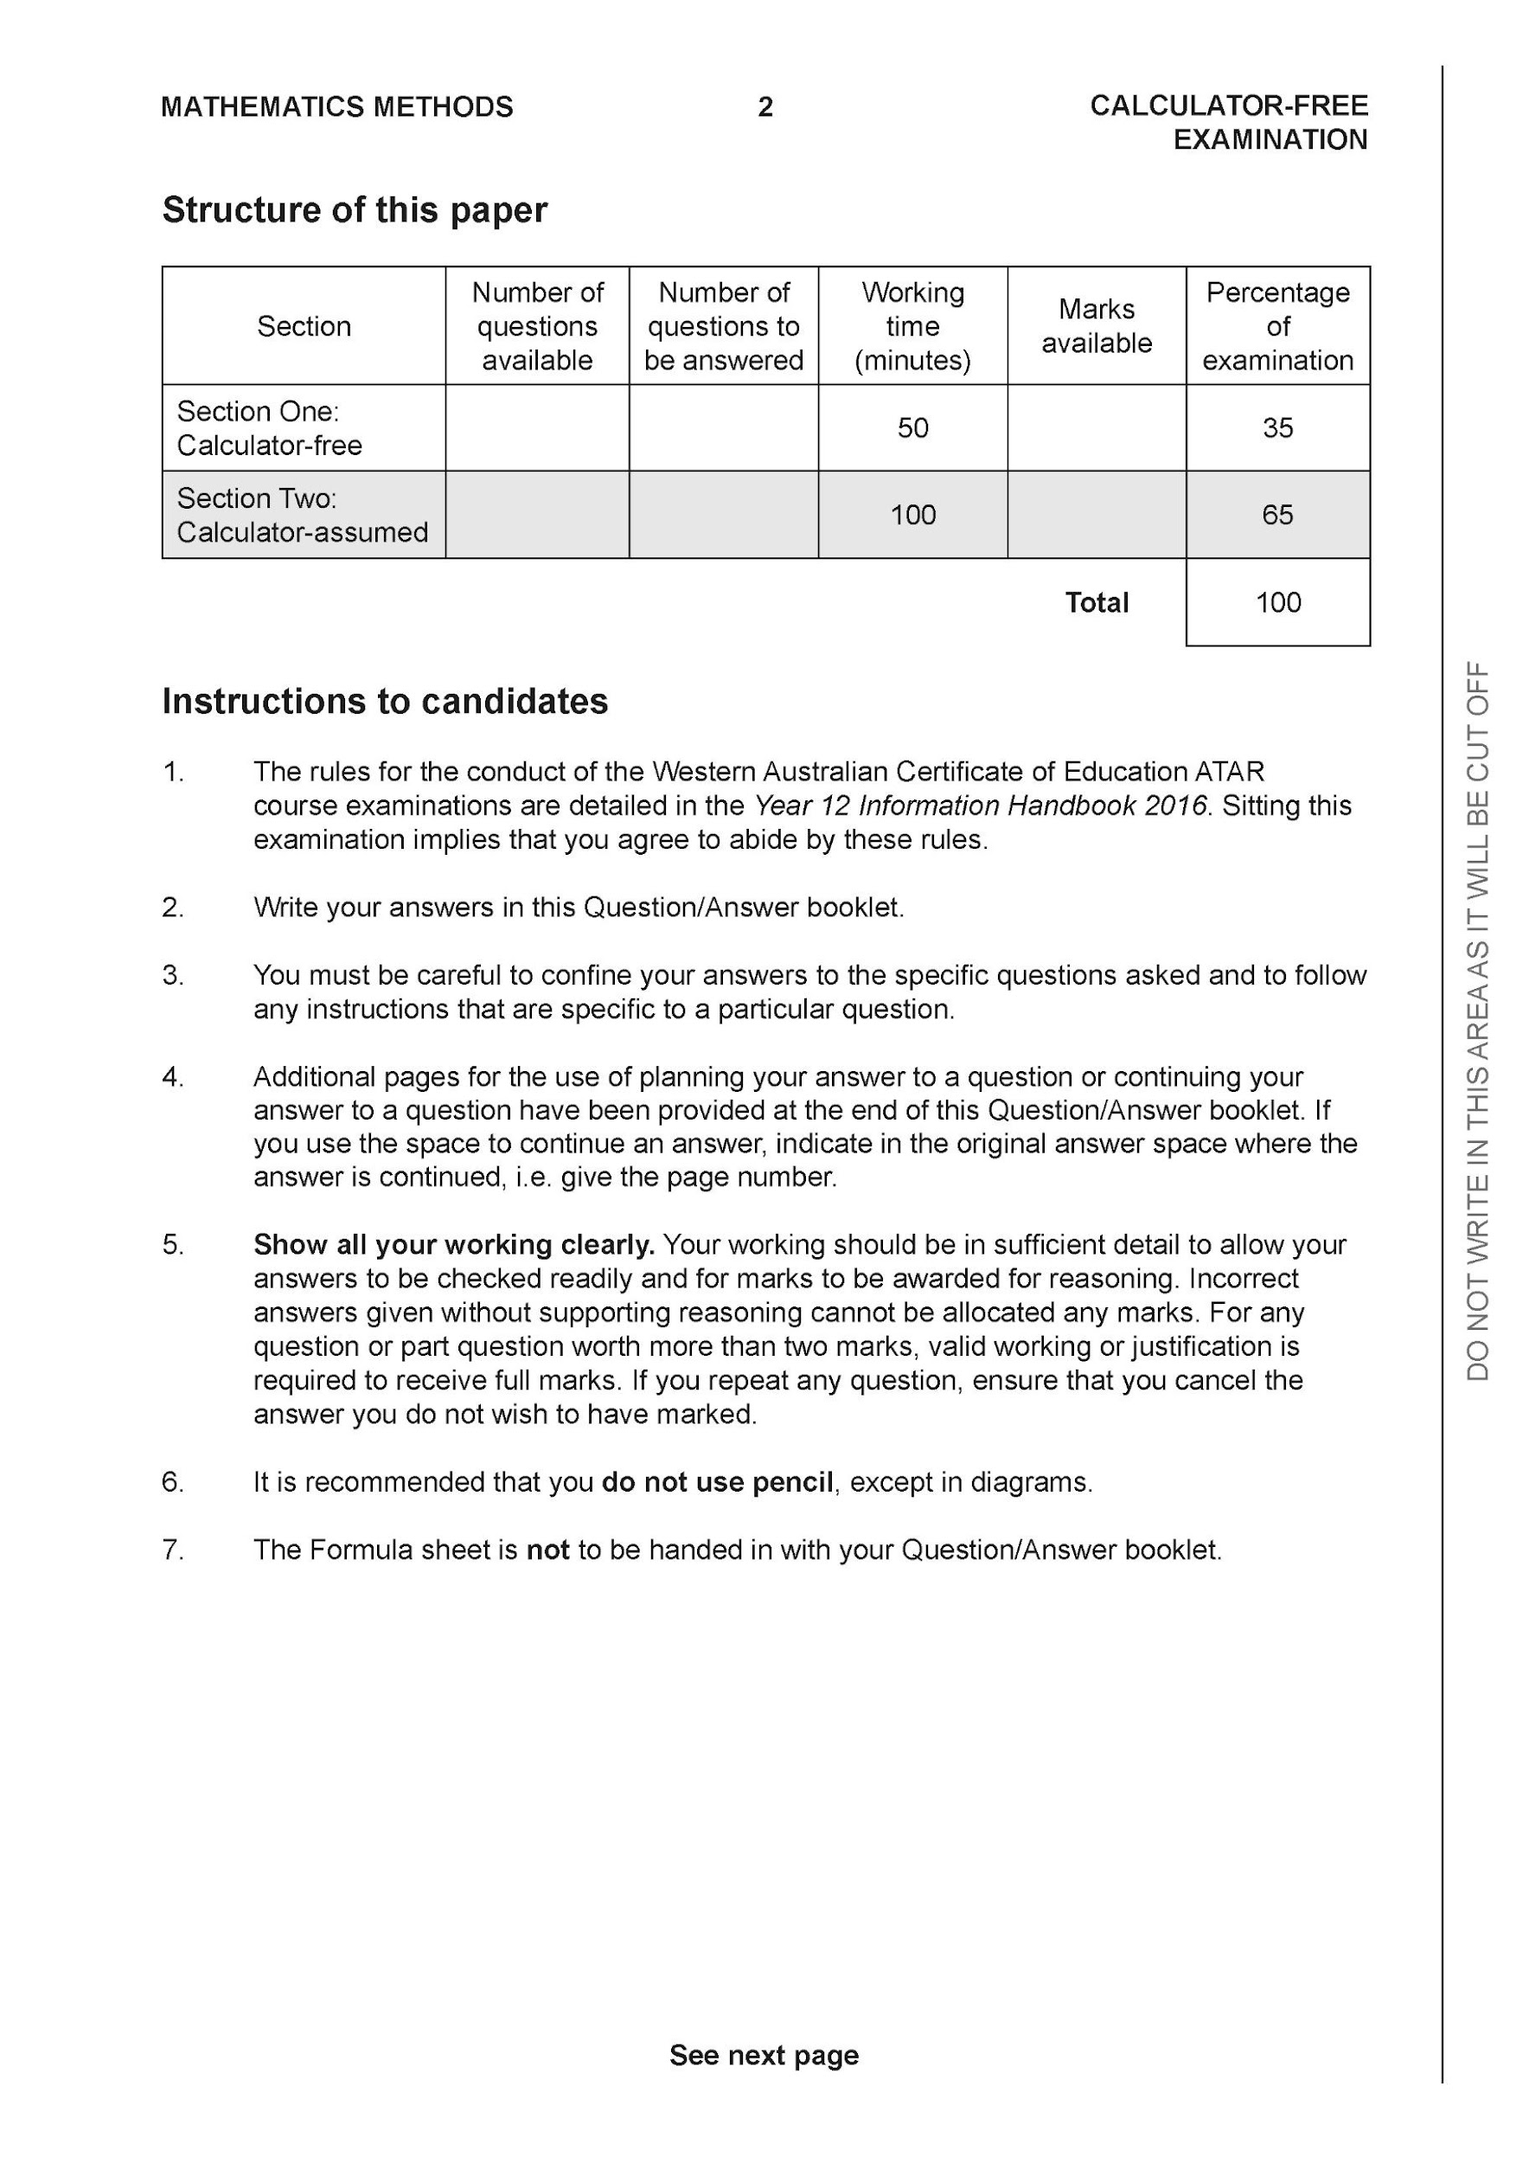

Section One: Calculator-free (51 Marks)

This section has eight (8) questions. Answer all questions. Write your answers in the spaces provided.

Spare pages are included at the end of this booklet. They can be used for planning your responses and/or as additional space if required to continue an answer.
● Planning: If you use the spare pages for planning, indicate this clearly at the top of the page.
● Continuing an answer: If you need to use the space to continue an answer, indicate in the original answer space where the answer is continued, i.e. give the page number. Fill in the number of the question that you are continuing to answer at the top of the page.

Working time: 50 minutes.

Question 1 (4 marks)

Evaluate

Question 2 (6 marks)

Consider a plane that contains the following points .

- Determine a normal vector to the plane. (4 marks)

- Determine a cartesian equation for the plane. (2 marks)

Question 3 (6 marks)

Sketch the function on the axes below, labelling important features.

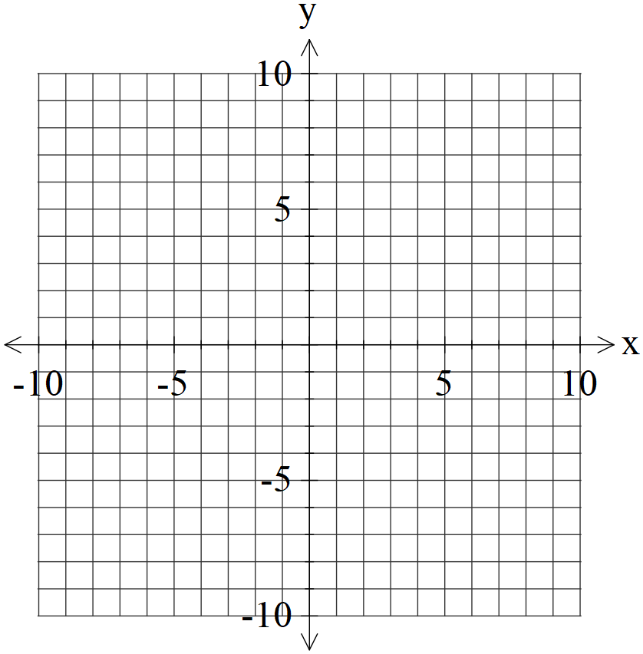

Question 4 (6 marks)

- Solve the following system of linear equations. (3 marks)

- Solve for all possible values of for the system below for each of the following scenarios. (3 marks)

- Unique solution.
- Infinite solutions
- No solutions.

Question 5 (6 marks)
Consider the function drawn below.
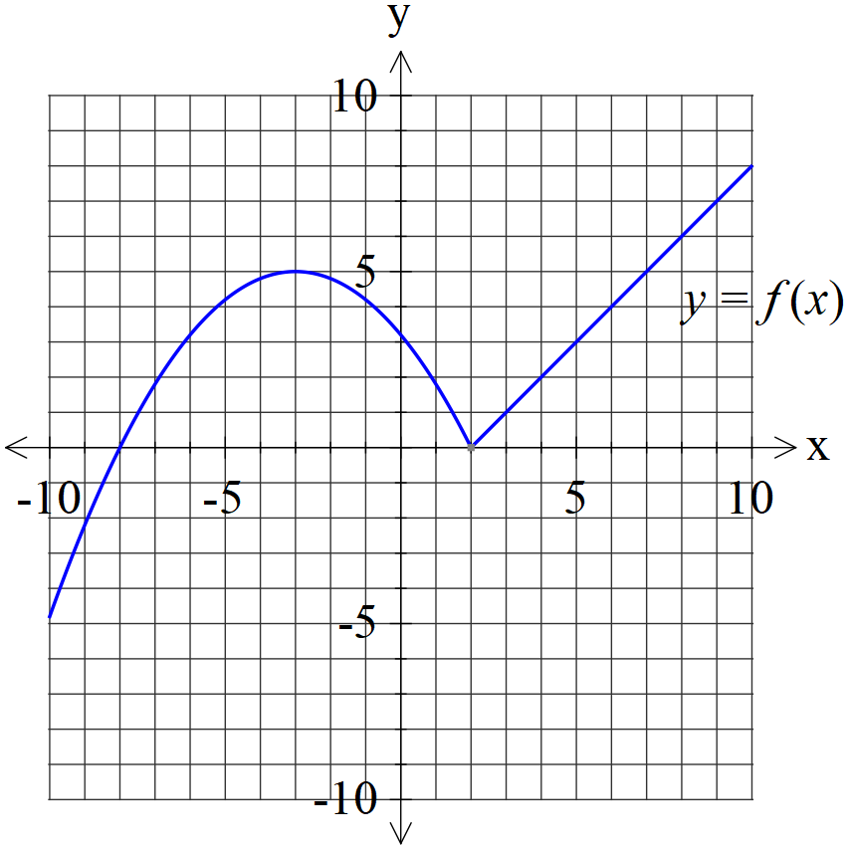
- Plot on the axes below. (2 marks)
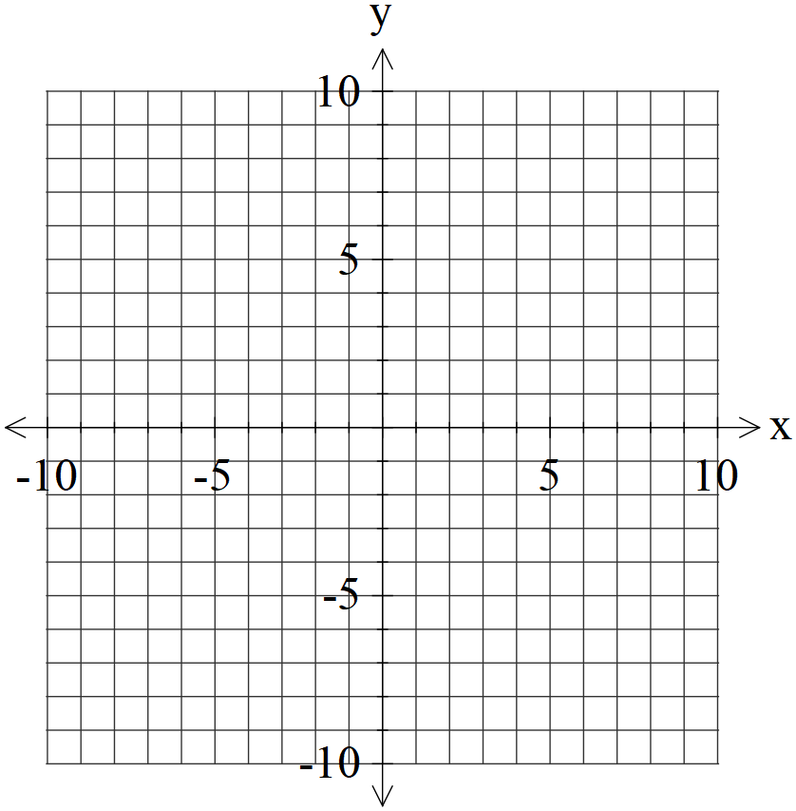
- Plot on the axes below. (4 marks)


Question 6 (9 marks)

Consider the function with domain .
Let .
- Determine the domain and range of . (2 marks)

- By using implicit differentiation show that is of the form where is a constant. (4 marks)

- Evaluate with substitution . (3 marks)

Question 7 (7 marks)

- Given that with constants. Solve for . (4 marks)

- Hence determine an expression for . (3 marks)

Question 8 (7 marks)

Evaluate the following integrals.
- (3 marks)

- (4 marks)
Additional working space
Question number:

Additional working space
Question number:

Additional working space
Question number:

Acknowledgements

